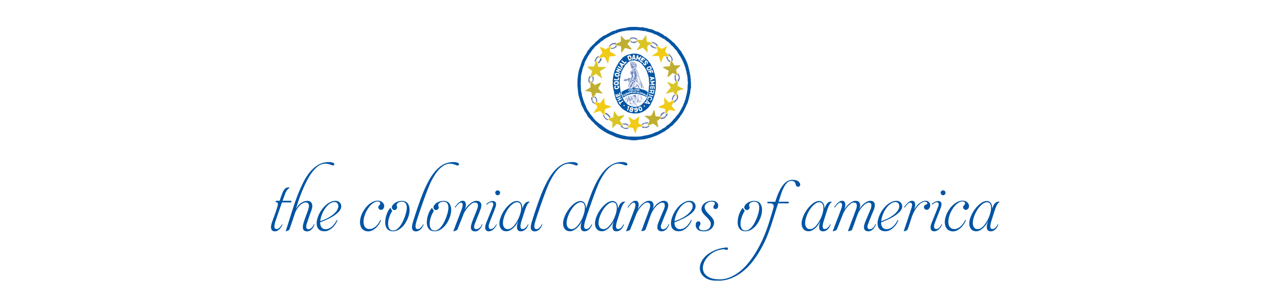
The us
417 East 61st Street | New York, New York | 10065 | 212.838.5489

